Day 24
Task1: Factory method
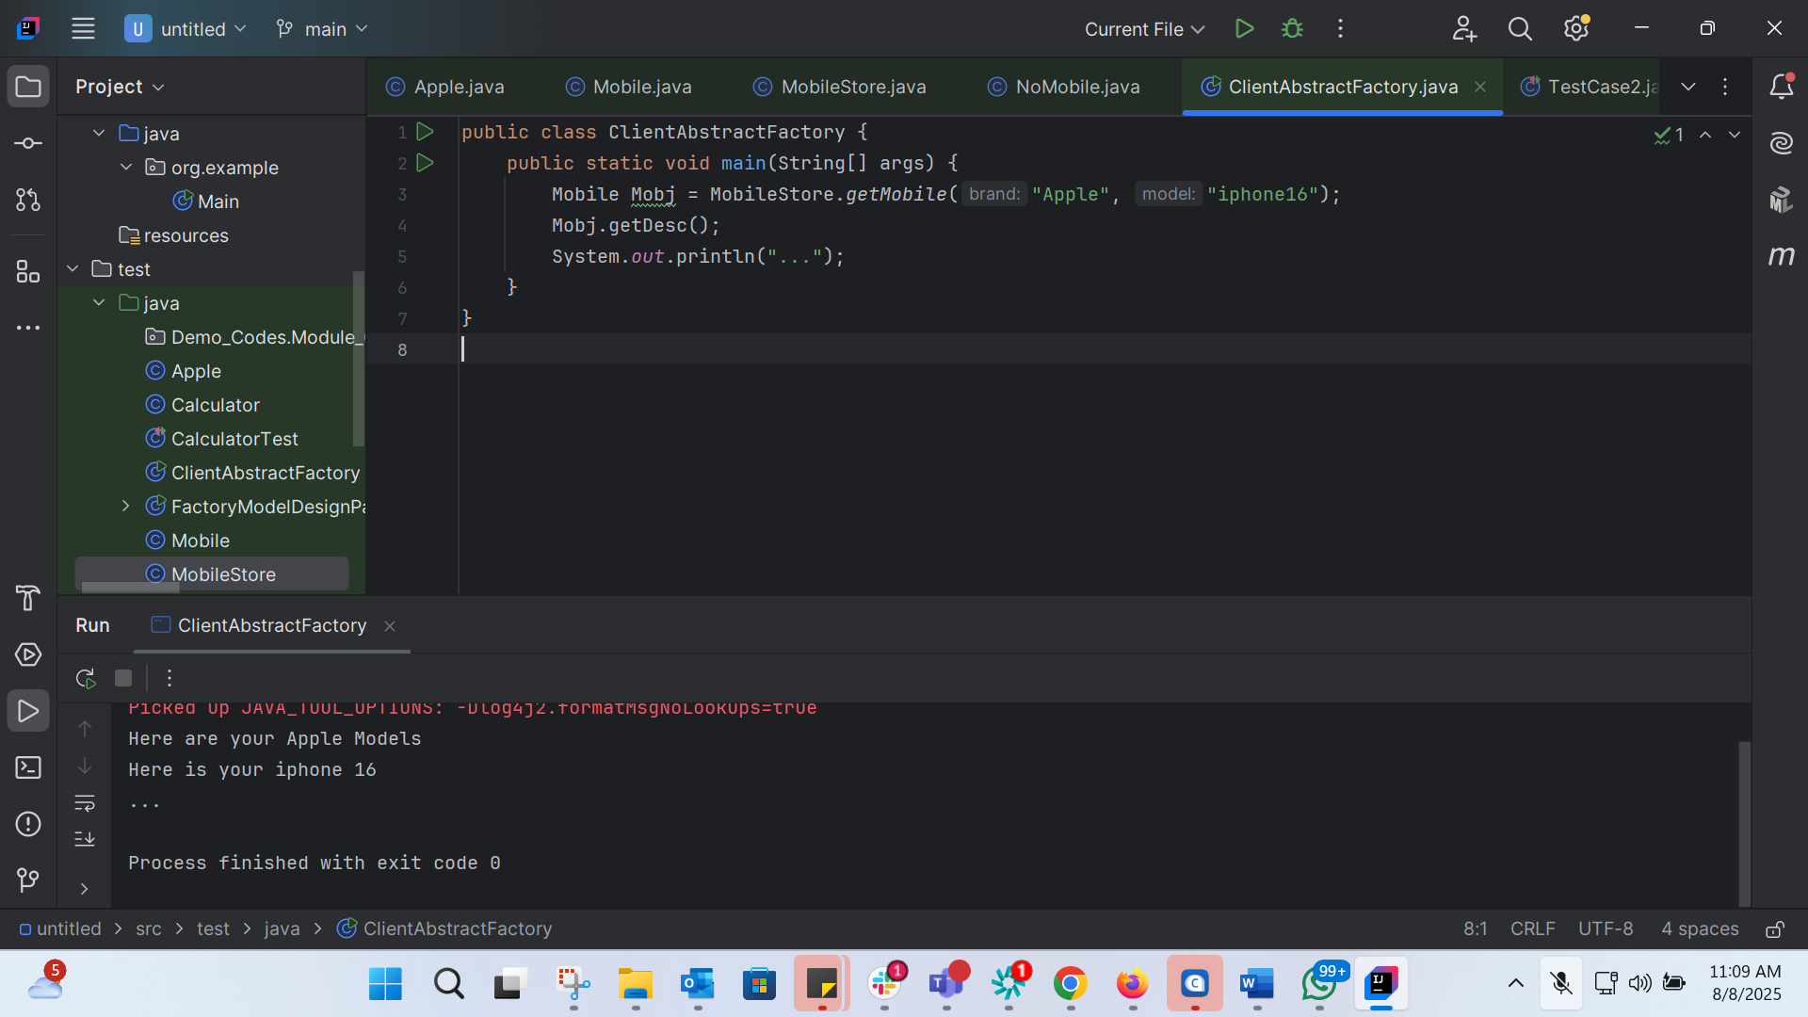
Task 2: Builder method Design pattern

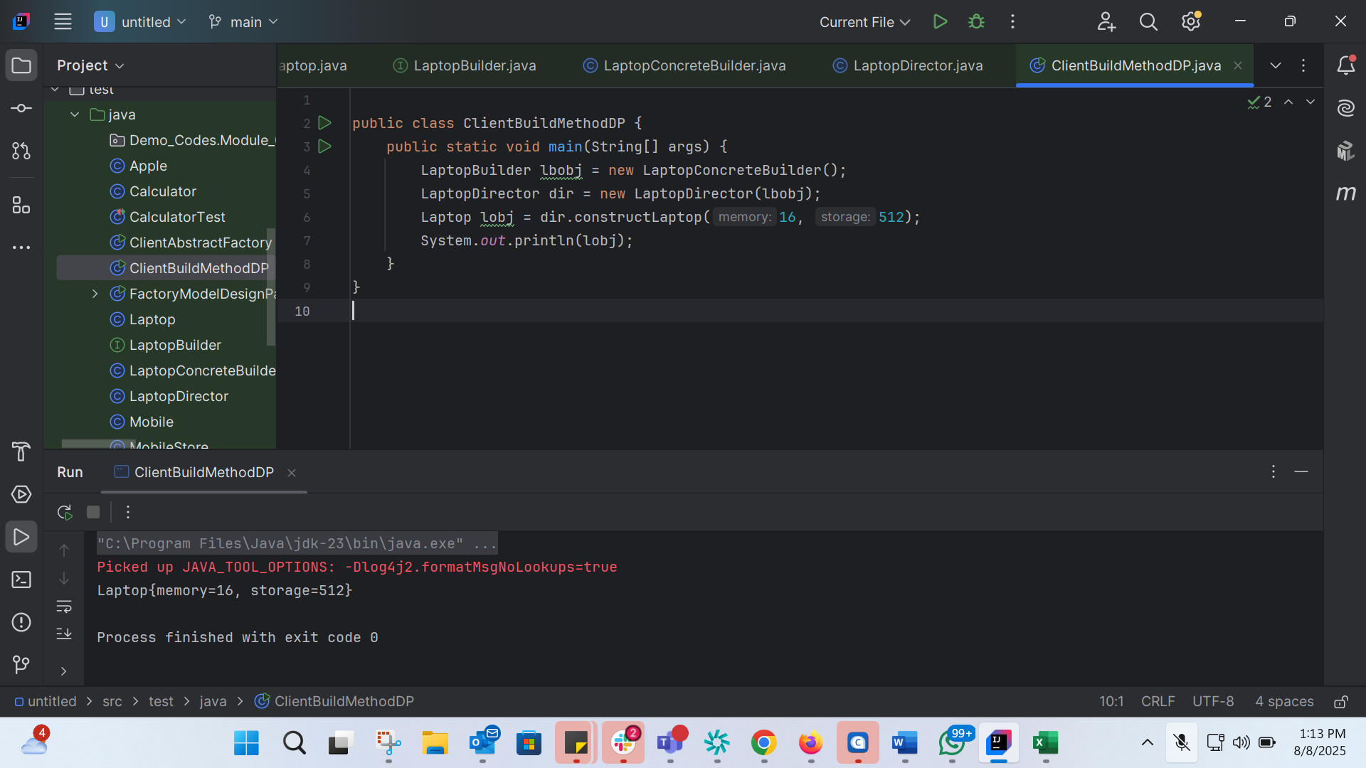

Task 3: Prototype Design Pattern Implementation

